NAME_____________________________________________________________________

2025 TERM 1 MZIMBA NORTH DISTRICT EXAMINATIONS

BIOLOGY FORM 2

(100 marks)

DATE: December, 2025 Time allowed: 2hours
(7:30 – 9:30Am)

INSTRUCTIONS:
1. Write your name on top of every page
2. This paper contains 10 printed pages, Section A and Section B. Please check
3. Answer all questions in the spaces provided

©MZN-T1-2025

SECTION A (20 Marks)

Answer all questions in this section. Encircle the letter corresponding to the correct answer. Each question carries 1 mark.

1. What is an investigation?
a. Activity carried out when one already knows the truth about something
b. Activity to be carried out to find out something.
c. Activity carried out to hide the truth.
d. Activity carried out to prove that someone is wrong.

2. Which list among the ones given below shows conditions necessary for photosynthesis?
a. Carbon dioxide, oxygen, water and light
b. Carbon dioxide, water, light, chlorophyll.
c. Carbon dioxide and water.
d. Nitrogen, carbon dioxide, water and light

3. Which equipment is used to determine temperature from a child?
a. Ordinary thermometer
b. veterinary thermometer
c. barometer
d. clinical thermometer

4. What is a hypothesis?
- A true statement
- A statement with a fact
- A statement with proposed explanation on a given observation
- A question in an investigation

5. Which of the following is not an external part of a leaf?
- Leaf margin
- Lamina
- Petiole
- Xylem

6. The part of a leaf which controls the amount of water lost through evaporation is called
- Sheath
- Xylem
- Stomata
- Guard cells

7. Which of the following best describes invertebrates?
a. Has a pair of tentacles
b. Has exoskeleton
c. Has pincers
d. Has segmented body

8. Which one of the following is not an example of leaf arrangements?
- Whorl
- Alternate
- Opposite
- Venation
Figure 1 shows part of the human digestive system. Use it to answer Question 9 and 11.
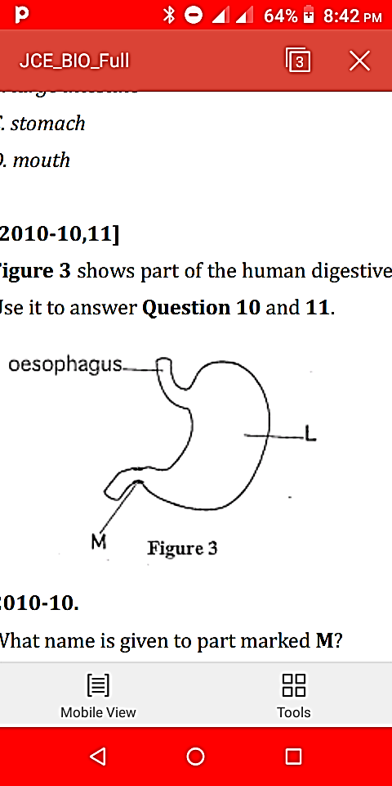 M
Figure 1

9. What name is given to part marked M?
a. anal sphincter
b. duodenum
c. pyloric sphincter
d. ileum

10. Which of the following digestive juices is secreted in part marked L?

a. saliva
b. pancreatic juice
c. gastric juice
d. intestinal juice

11. Which of the following acid is secreted in part marked L?
a. Sulphuric acid
b. citric acid
c. hydrochloric acid
d. Nitric acid

12. Which blood vessel carries digested food from the small intestines to the liver
a. Hepatic portal vein
b. Hepatic vein
c. Hepatic artery
d. Renal artery

13. A drop of food solution was placed on a white paper. what would be the result for the presence of lipids in the food?
a. Blue black
b. Brick red
c. Translucent spot
d. Purple
14. Which of the following lists of food nutrients are necessary for the prevention of anaemia?
a. Proteins, Carbohydrates and Iron
b. Proteins, Carbohydrates and Vitamins C
c. Proteins, Iron and Vitamin C
d. Carbohydrates, Iron and Vitamin C

15. Which of the following should not be included in an investigation in biology?
a. aim
b. hypothesis
c. variables
d. conclusion

16. Why do scientists repeat a scientific investigation?
a. minimizing errors
b. comparing results
c. reaching a conclusion
d. rejecting hypothesis
Figure 2 is the diagram showing invertebrate. Use it to answer question 17 below:
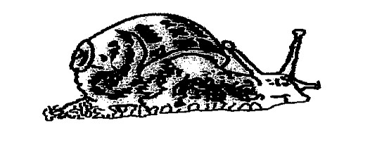

17. To which group of invertebrates does it belong?
a. nematodes
b. crustacean
c. molluscs
d. coelenterates

18. Which is the correct order of the steps to be followed when donating blood?
a. Pre-donation counselling,venipuncture,post-donation counselling and eligibility criteria procedures
b. Pre-donation counselling, eligibility criteria procedures,post-donation counselling and venipuncture
c. Pre-donation counselling,eligibility criteria procedures, venipuncture and post-donation counselling
d. Pre-donation counselling, post-donation counselling,eligibility criteria procedures and venipuncture

19. which of the following is the raw material for photosynthesis
a. water
b. chlorophyll
c. glucose
d. nitrogen
20. Canines teeth in mammals are used for
a. crush and grind food
b. decorating the mouth
c. cutting and biting
d. piercing and holding food

Section B (50 marks)
Answer all the questions in this section in the spaces provided.

- a. Define the term photosynthesis?
_______________________________________________________________________________________________________________________________________________ (1 Marks)
b. Write a word equation for the process of photosynthesis. (4 marks)

. c. Balance the following chemical equation for photosynthesis ( 3marks)
6________ + 6C ___________ Light _____________ + 6O₂

Chlorophyll

d. Describe two processes that take place during the light stage of photosynthesis.
_____________________________________________________________________________________________________________________________________________________________________________________________________________________________________________________________________________________________________________________________________________________________________________________________________________________________________________________________________ (4 Marks)
22. Figure 3 shows the internal structure of a leaf. Identify parts labelled A, B and C.
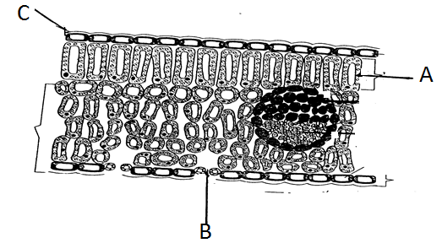
A: _________________________________________________________________ ( 1 marks)
B: __________________________________________________________________ (1 marks)
C: __________________________________________________________________ (1 marks)
b. Explain two reasons why some leaves have been modified into sharp spines or hooks.
_____________________________________________________________________________
_____________________________________________________________________________
_____________________________________________________________________________
________________________________________________________________ ____ (4 Marks)
23. Figure 4 shows the root system of a plant, study it and answer the questions that follows:
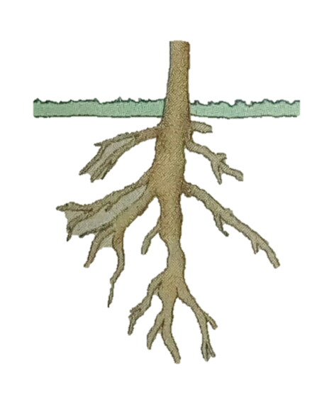
a. What type of root system is shown in the diagram?
_________________________________________________________________ (1Mark)
b. Apart from the root system above, state any other two types of roots
_____________________________________________________________________________
_________________________________________________________________ (2 marks)
24. What part of a plant transports:
a. Water. ______________________________________________________________ (1mark)
b. Manufactured food _____________________________________________________(1mark)
25. State any two functions of roots to a plant.
___________________________________________________________________________________________________________________________________________________________________________________________________________________________________________________________________________________________________ (2 marks)
26. Figure 5 is a diagram of a leaf. Study it and answer the questions that follow:

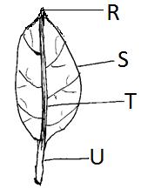

a. State the parts labeled R to U.
R________________________________(1 Mark) T ___________________________ (1 Mark)
S________________________________ (1 Mark) T __________________________ (1 Mark)
b. Explain two functions of the leaf to a plant?
_____________________________________________________________________________
_____________________________________________________________________________
_____________________________________________________________________________
_____________________________________________________________________ (2 Marks)
c. Mention two types of leaf venations.
_____________________________________________________________________________
_____________________________________________________________________ (2 Marks)

Figure 6 are diagrams of internal structure of stem A and B. Use it to answer questions 27 and 28 below:
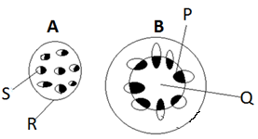

a. Name the parts labeled P, Q, R and S.
P __________________________________________________________________ (1 mark)
Q ___________________________________________________________________ (1 mark)
R ___________________________________________________________________ (1 mark)
S___________________________________________________________________ (1 mark)
b. Which of the stems is for monocotyledonous plant?
_____________________________________________________________________(1 mark)
c. Name two internal structures of a dicotyledonous plant that forms the vascular bundle ______________________________________________________________________________________________________________________________________________________________________________________________________________________ (2 Marks)
29. a. Explain why it is advisable to breathe air through the nasal passage than through the mouth,
_____________________________________________________________________________
_____________________________________________________________________________
_____________________________________________________________________ (2 Marks)
b. Explain one function of rings of cartilage that line the trachea.
_____________________________________________________________________________
_____________________________________________________________________ (2 Marks)
30. Figure 7 shows part of the human digestive system, use it to answer the questions that follow:
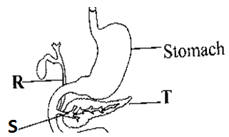
a. Name the parts labelled R and S.
R: ______________________________________________________________ (1 Mark)
S: ______________________________________________________________ (1 Mark)
b. Mention any one enzyme produced by part marked T.
_________________________________________________________________ (1 Mark)
c. Explain any one way in which the acid found in the stomach is important.
___________________________________________________________________________________________________________________________________________________________________________________________________________________________________________________________________________________________________ (2 Marks)
Section c (30marks)
Answer all the questions in this section. Your answers should be in an essay form.
31. Describe any five adaptations of ileum to its function __________________________________________________________________________________________________________________________________________________________________________________________________________________________________________________________________________________________________________________________________________________________________________________________________________________________________________________________________________________________________________________________________________________________________________________________________________________________________________________________________________________________________________________________________________________________________________________________________________________________________________________________________________________________________________________________________________________________________________________________________________________________________________________________________________________________________________________________________________________________________________________________________________________________________________________________________________________________________________________________________________________________________________________________________________________________________________________________________________________________________________________________________________________________________________________________________________________________________________________________________________________________________________________________________________________________________________________________________________________________________________________________________________________________________________________________________________________________________________________________________________________________________________________________________________________________________________________________________________________________________________________________________________________________________________________________________________________________________(10 Marks)

32. Explain any five general effects of deficiency diseases.
_____________________________________________________________________________________________________________________________________________________________________________________________________________________________________________________________________________________________________________________________________________________________________________________________________________________________________________________________________________________________________________________________________________________________________________________________________________________________________________________________________________________________________________________________________________________________________________________________________________________________________________________________________________________________________________________________________________________________________________________________________________________________________________________________________________________________________________________________________________________________________________________________________________________________________________________________________________________________________________________________________________________________________________________________________________________________________________________________________________________________________________________________________________________________________________________________________________________________________________________________________________________________________________________________________________________________________________________________________________________________________________________________________________________________________________________________________________________________________________________________________________________________________________________________________________________________________________________________________________________________________________________________________________________________________________________________________________________________________________________________________________________________________________________________________________________________________________________ (10 Marks)

33.Describe any five parts .of which the internal structure of a leaf is composed.
__________________________________________________________________________________________________________________________________________________________________________________________________________________________________________________________________________________________________________________________________________________________________________________________________________________________________________________________________________________________________________________________________________________________________________________________________________________________________________________________________________________________________________________________________________________________________________________________________________________________________________________________________________________________________________________________________________________________________________________________________________________________________________________________________________________________________________________________________________________________________________________________________________________________________________________________________________________________________________________________________________________________________________________________________________________________________________________________________________________________________________________________________________________________________________________________________________________________________________________________________________________________________________________________________________________________________________________________________________________________________________________________________________________________________________________________________________________________________________________________________________________________________________________________________________________________________________________________________________________(10 Marks)

END OF QUESTION PAPER
NB: This paper contains 10 printed pages!!!

